Standard Operating Procedure

SHARPS SAFETY

Waste Management and Labeling

Overview
Sharps are sharp objects–e.g., needles, syringes with needles, scalpels, blades, disposable scissors, suture equipment, stylets, and trocars, broken test tubes, and glass that could be contaminated with biological samples, chemicals, radioactive materials or non-contaminated. This document summarizes proper collection, labeling and waste management of sharps

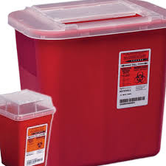
I. Sharps Contaminated with Biohazardous or Medical Waste:
Storage Requirements and Labeling:
Collect in a biohazardous sharps container that is red, rigid, puncture resistant and leak proof.
Waste Management:
Option 1:  Treat the sharps container for a minimum of 30 minutes at 121°C in an autoclave permitted for the treatment of medical waste and label it as “autoclaved.”  Submit an online Chemical Waste Collection Request via the EH&S website. Note on the request that the material has been autoclaved. Alternatively, leave the autoclaved sharps container at Bio II 4106, LSB 2204 or LSB 4218, where it will be picked up without a request. | Option 2:  Request pick‐up of un‐autoclaved sharps containers by the BNL Autoclave Core, which will autoclave and arrange for disposal for a fee:  https://www.cnsi.ucsb.edu/resources/facilities/autoclave‐core  Groups generating large quantities of biohazardous sharps waste must contract with a certified medical waste management company for pick‐up and disposal.

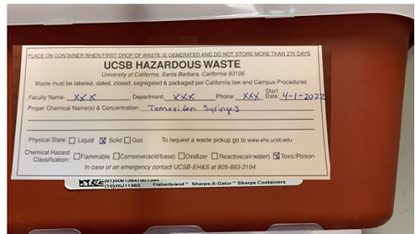
II. Sharps Contaminated with Hazardous Chemicals:
Storage Requirements and Labeling:
Cover any biohazard labels with a hazardous waste label and list the chemical constituents. Complete ALL sections of the label. Add the Month/Day/Year at which the sharps waste was first stored.
Waste Management:
Once the sharps container is full or is 9 months old (whichever occurs first), submit an online Chemical Waste Collection Request via the EH&S website.

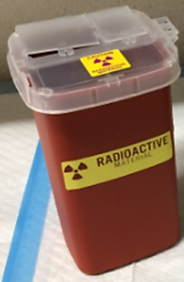
III. Sharps Contaminated Radioactive Material:
Storage Requirements and Labeling:
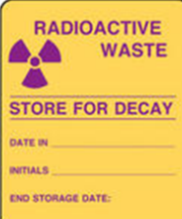
Cover any biohazard labels with a radioactive waste label and include the radioactive isotope.
Waste Management:
Submit an online Radioactive Waste Collection Request via the EH&S website.

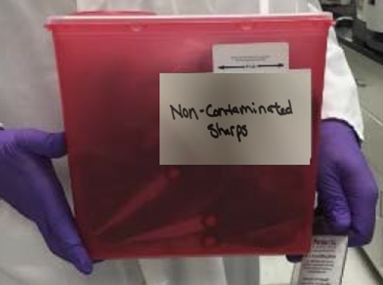
IV. Non-Contaminated Sharps
Storage Requirements and Labeling:
Cover any biohazard labels with a PLAIN label as shown on the picture. Write "Non-Chemical/Non-Medical Sharps" or "Non-Contaminated Sharps" on the label.
Do Not Use Hazardous Waste Labels for Non-Contaminated Sharps Collection!

Waste Management:
When the container is full, submit an online Chemical Waste Collection Request via the EH&S website.

V. Broken Laboratory Glass
Definition: Laboratory glass is defined as equipment generally made of pyrex, borosilicate, and quartz glass used for scientific experiments. Examples of laboratory glass include, but are not limited to, the following: beakers, flasks, graduated cylinders, stirring rods, test tubes, microscope slides, glass pipettes, glass petri dishes, and glass vials.
Glass items contaminated with biohazards, chemicals or radioactive materials such as pipettes, microscope slides, and capillary tubes are considered “sharps waste”. Under no circumstances should “sharps waste” be disposed of in the normal trash. (Sharps disposal procedures given above.)

Storage Requirements and Disposal:
1. Prior to utilizing the cardboard lab glass box, duct tape the bottom to ensure the container is secure.
Labs can use a 32gal. red lidded cart to house cardboard lab glass box for ease of transport. (Loose lab glass cannot be placed in red lidded carts.)
2. Place unwanted or broken lab glass in the cardboard lab glass box. Non‐lab glass, such as beverage
containers should be placed in recycling receptacles, and not disposed along with laboratory glass
waste.
3. When full, use duct tape to secure the lid to the body of the box. Be sure that the lid is securely
fastened to the body of the box so the contents remain inside.
4. Bring the cardboard lab glass box down to your building’s red lidded carts and place inside and re‐lock
the cart.
If you are using the 32gal. cart to house the cardboard glass box, roll the cart down to the
dumpster corral and leave for pick‐up. Carts are serviced on Saturdays.

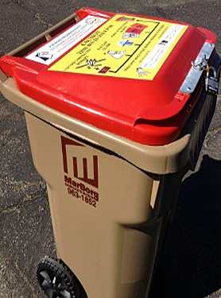
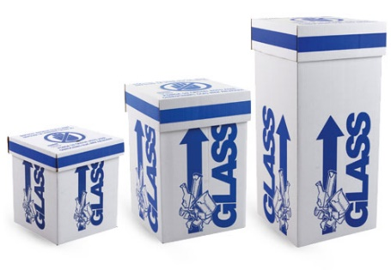

LANDFILL

Carts served by MarBorg on Saturdays
Questions: Matt O’Carroll
Cardboard Lab Glass Boxes
(and autoclaved Waste Bags)

First Aid and Personnel Exposure
- Clean the affected area. Wash needle sticks and cuts with soap and water. The laboratory sink, emergency shower and eye wash stations will be used as necessary to flush affected areas with water for several minutes.
- Report the incident. Exposures must be reported to the PI or Lab Safety Contact immediately. Staff exposures or injuries are recorded with an Employer’s First Report: https://www.ehs.ucsb.edu/workcomp
Student exposures or injuries are filed via this webpage: https://www.ehs.ucsb.edu/riskmanagement/incident-reporting
- Seek treatment. Healthcare personnel treating exposed patients must be informed of the hazardous materials involved in the exposure.
Employees and personnel on University pay status seek treatment:
During work hours: Sansum Occupational Medicine Center, 101 South Patterson Avenue, Santa Barbara, CA 93111,
and
after business hours: Sansum Urgent Care Center, 215 Pesetas Lane, Santa Barbara, CA 93110.
Students are to seek treatment
During work hours: UCSB Student Health Services, Building 588, at El Colegio and Ocean Road, Santa Barbara CA 93117,
and after business hours at Goleta Valley Cottage Hospital, 351 S. Patterson Avenue, Goleta CA 93117.

