Setting up a laboratory hazard assessment and chemical inventory

Log into https://ehs.ucop.edu/ with your NetID and navigate to the home page.
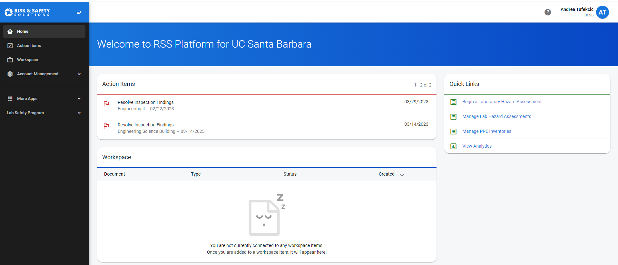

First, click on profile by clicking your name in the top right corner to determine if you have a group associated with your account. If not, follow the instructions below to establish one. If you have a group, continue with setting up your LHAT.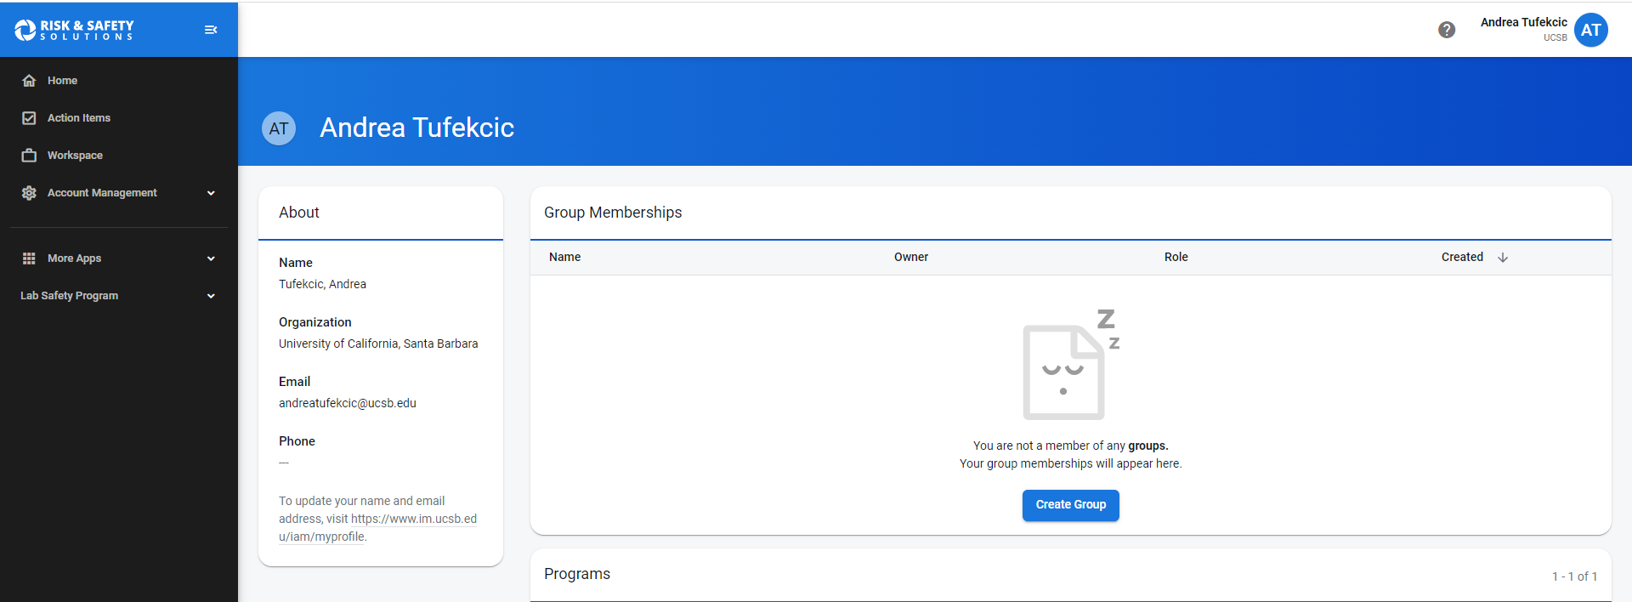
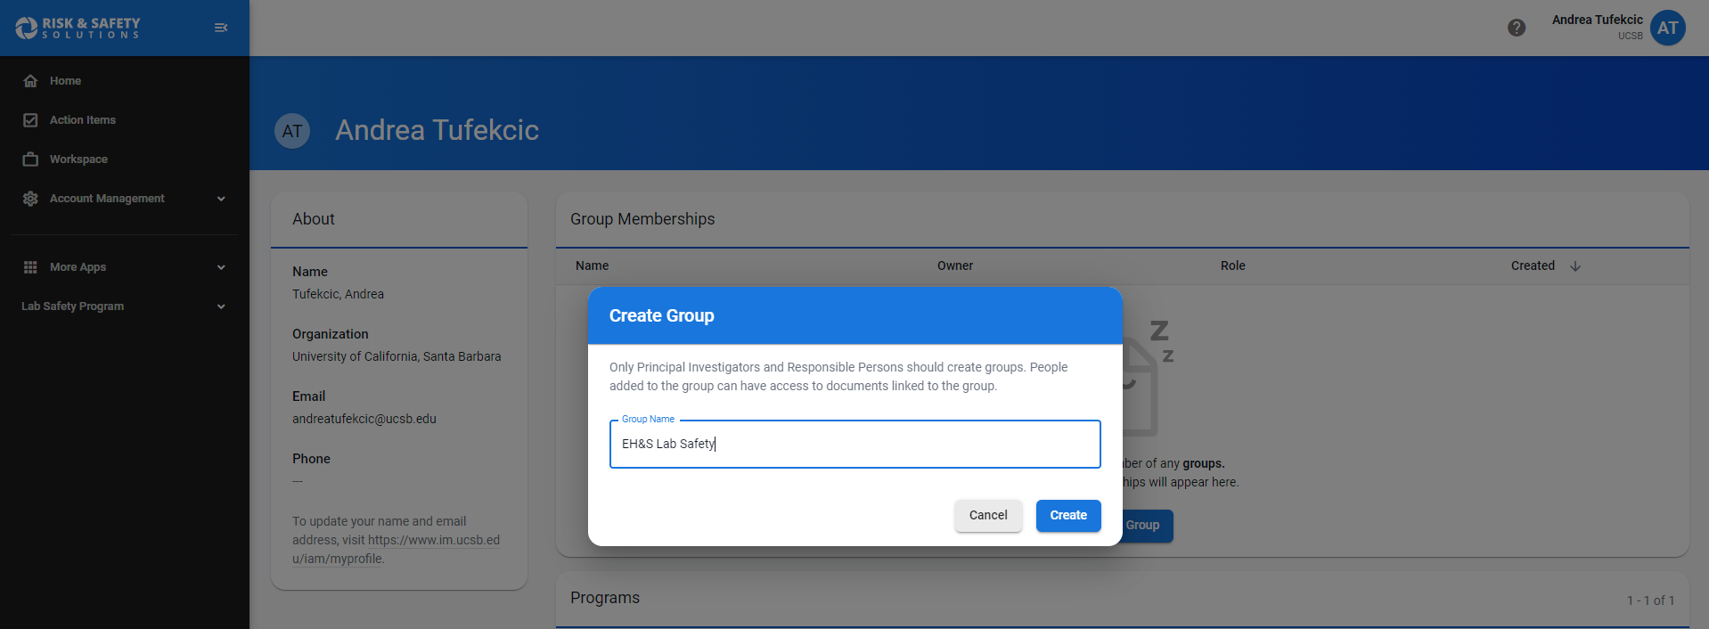
Click on ‘create a lab hazard assessment’ by returning to the homepage and clicking on the Begin a Laboratory Assessment quick link on the right toolbar.

Follow the prompts to add relevant laboratory information, including your current lab roster, lab locations, and all relevant hazards.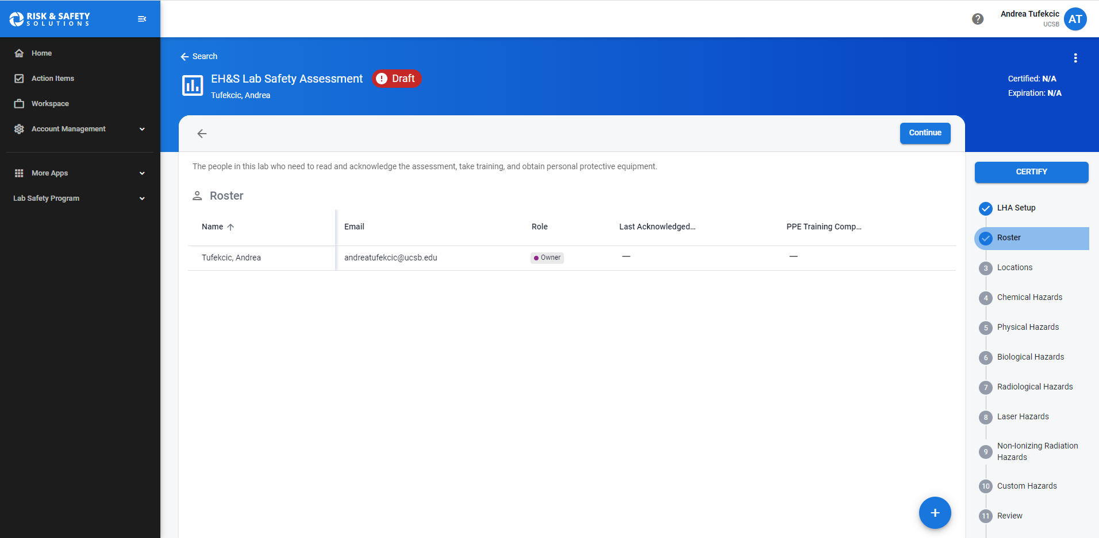
Click the blue plus icon under roster to add additional lab members via their UCSB email. Please use the UCSB domain whenever possible so all training records can port over from the UC Learning Center properly. 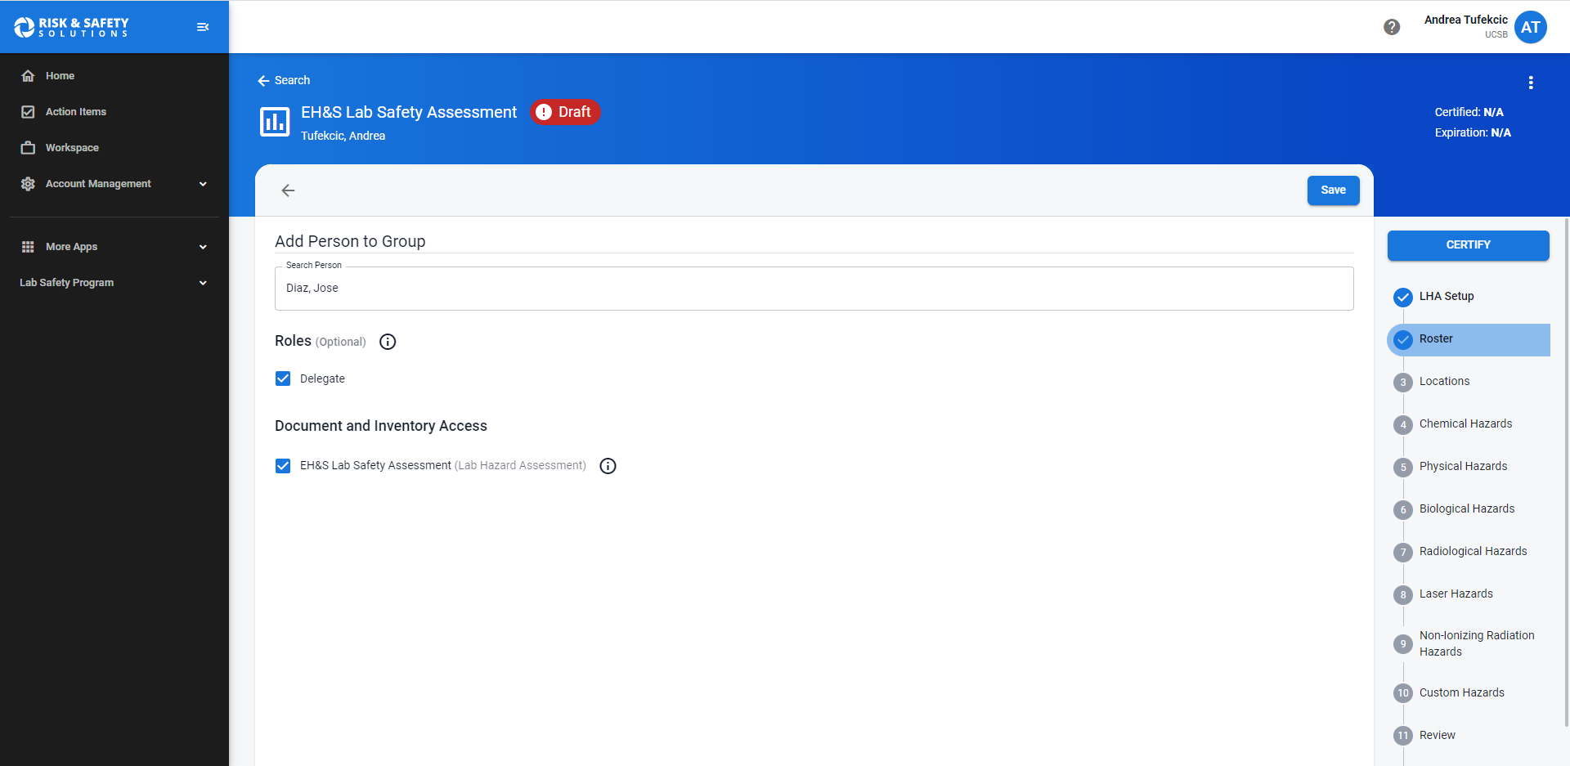

Hit certify when complete.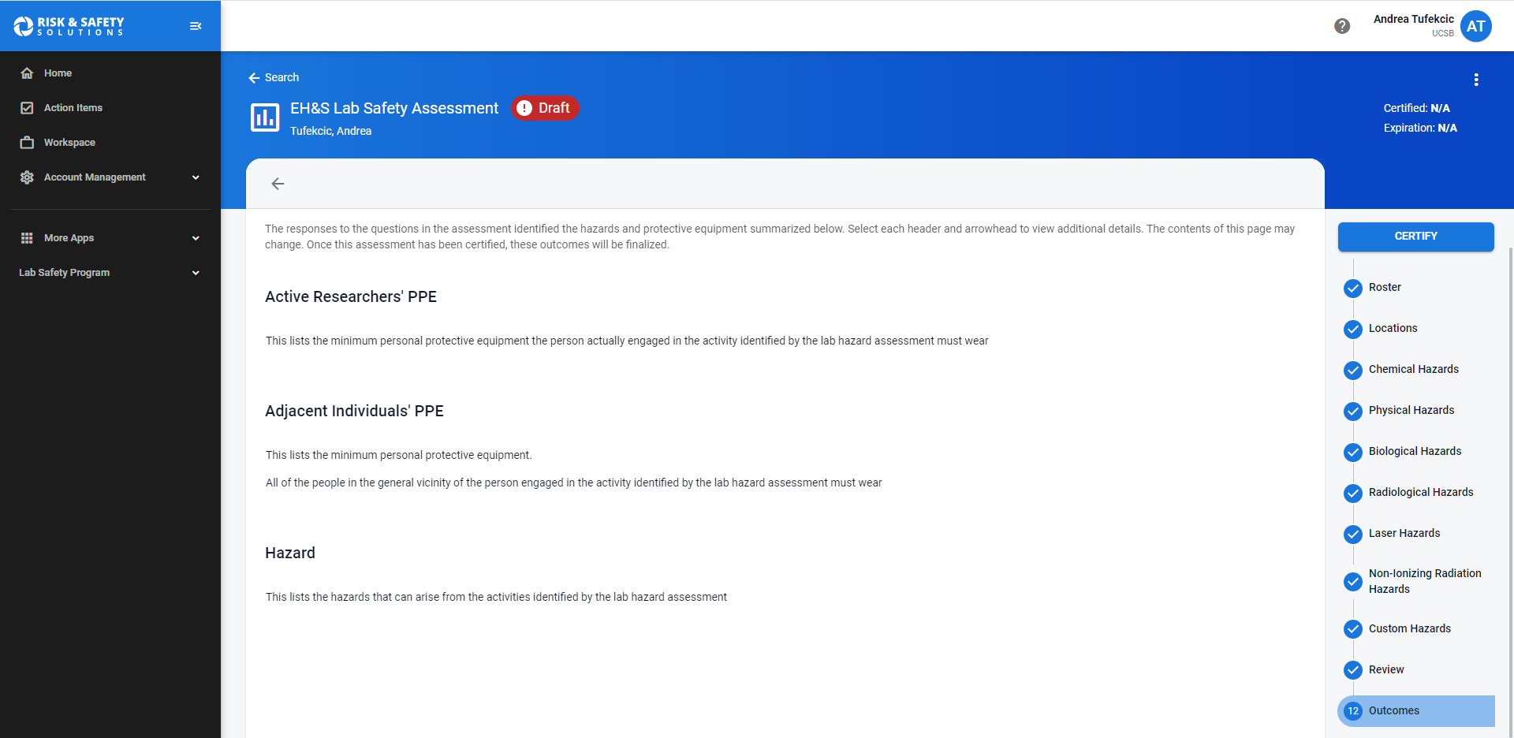
LHATs should be recertified every three years. New lab members should review and acknowledge the LHAT upon joining a lab. They will also be prompted to review the PPE training, where they will receive a voucher to obtain any equipment deemed necessary.

Setting up a chemical inventory

Navigate to https://ehs.ucop.edu/chemicals, and click create a new inventory.
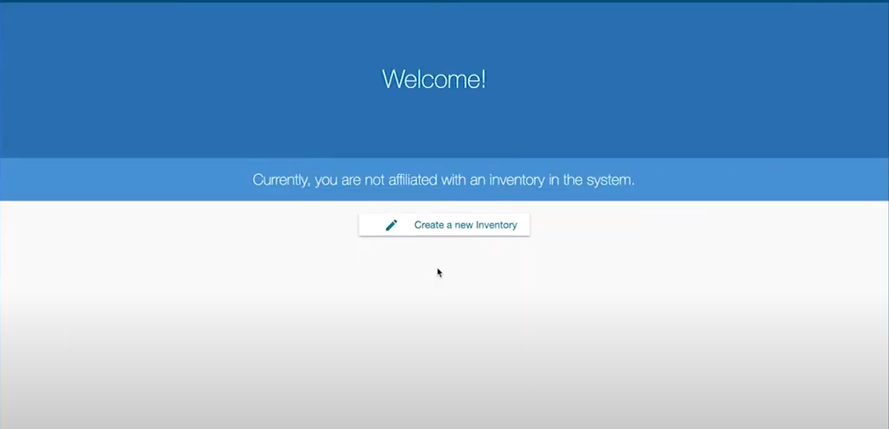

Designate sublocations for your lab spaces. These can be as large as an entire room, or
as granular as a shelf on a cabinet. Select any appropriate GHS pictograms to indicate
the chemical hazards that will be present in that sublocation.

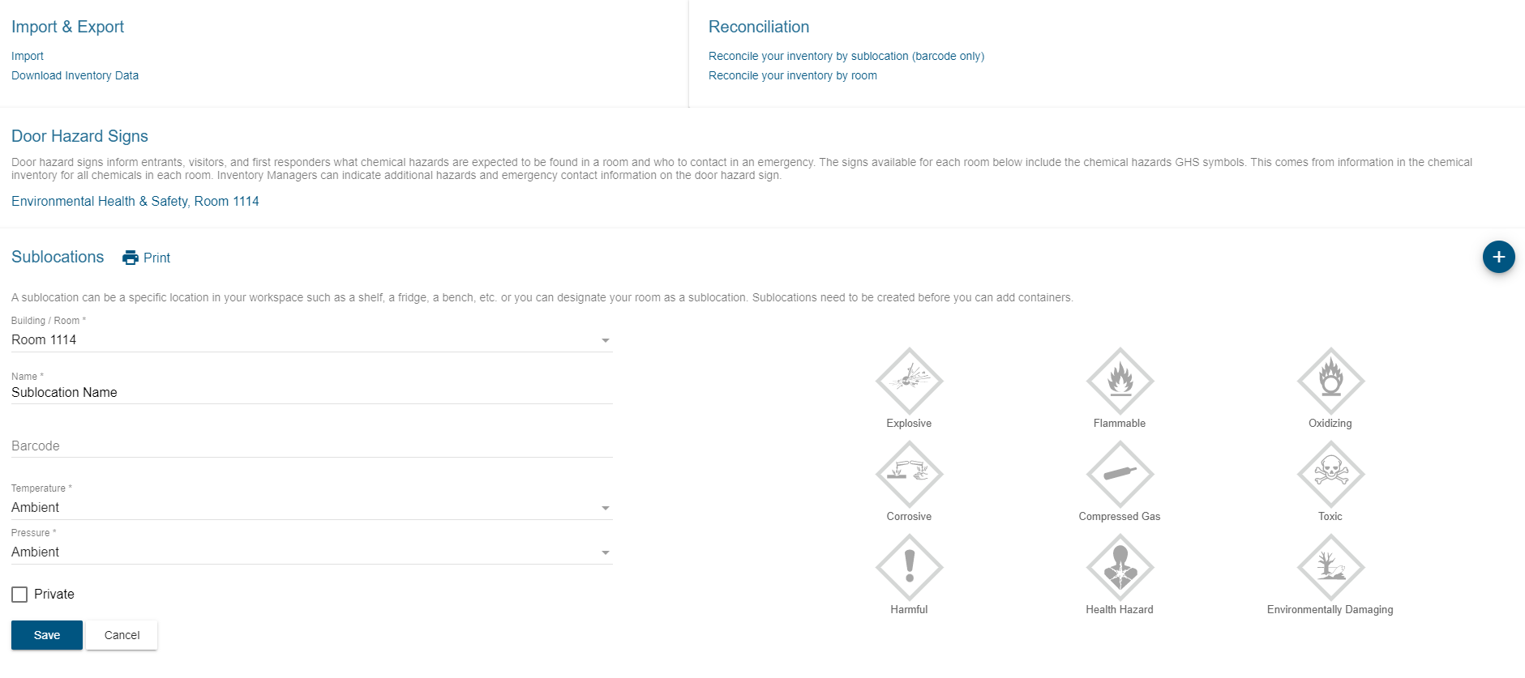
RSS has produced video tutorials for setting up a new chemical inventory and designating sublocations, which can be accessed at this link.
Once sublocations are set, you can then add in the appropriate chemical containers by clicking Add to Inventory and searching by name, CAS #, or product number.
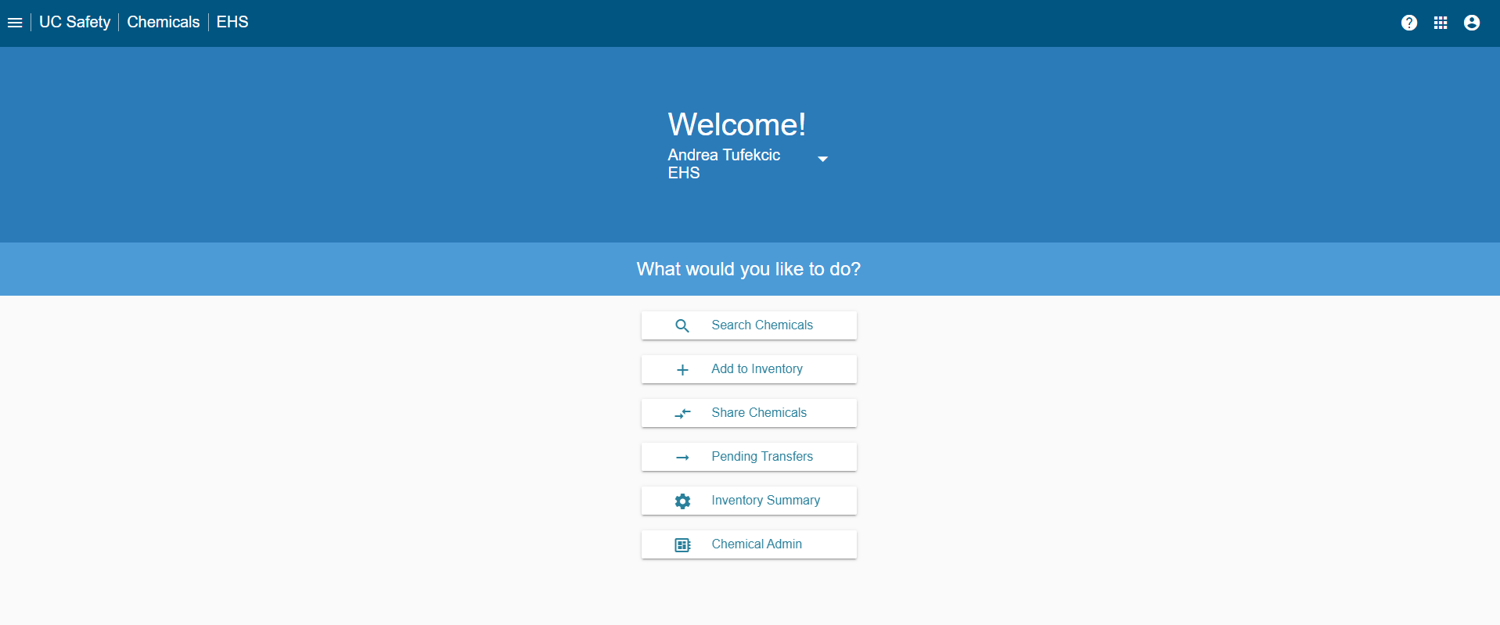

A video tutorial for adding chemicals to a chemical inventory can be accessed at this link.

If you already maintain a separate inventory and wish to add it, click the import button under the Import & Export header, and follow the instructions to format your inventory appropriately. Make sure to include the CAS #, physical state, and location of each chemical you are importing.

